County Land Session
The land work for the County programme is based on the performance pyramid used by British swimming and key exercises elected are designed to improve starts, turns and free swimming.
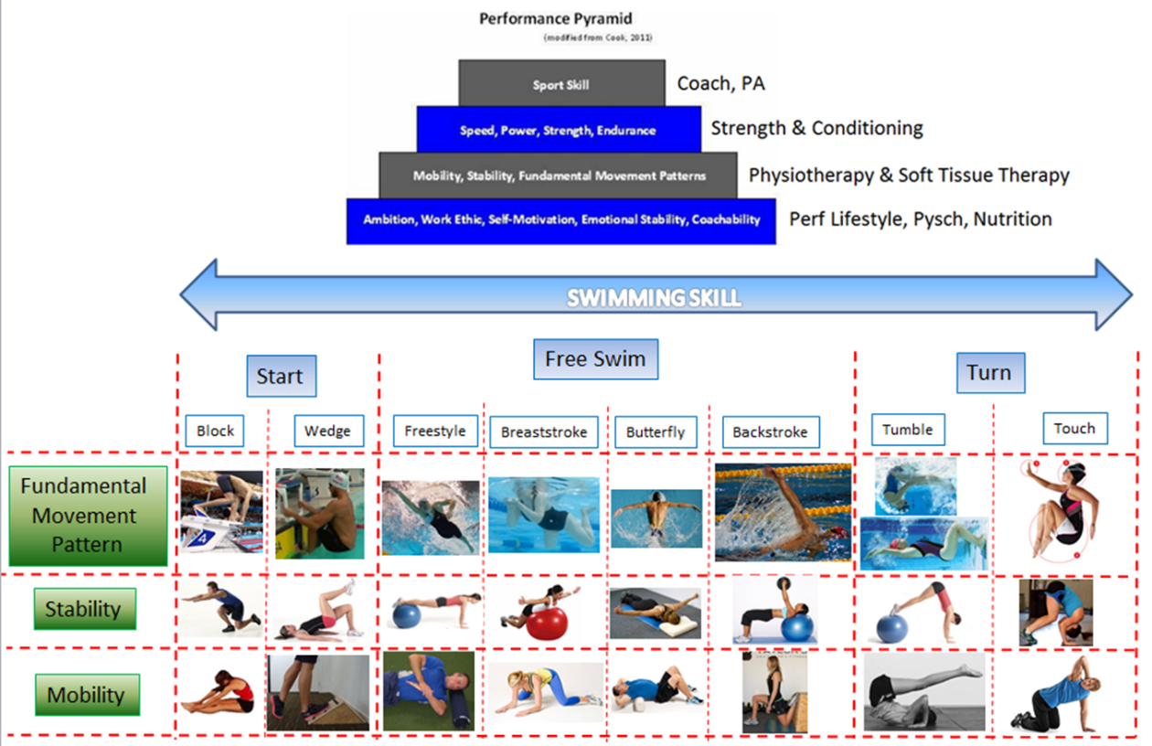
Key emphasis for 11 year olds are outlined by the chart below which British swimming have produced as part of their new British swimming document.( Youth Development Model)
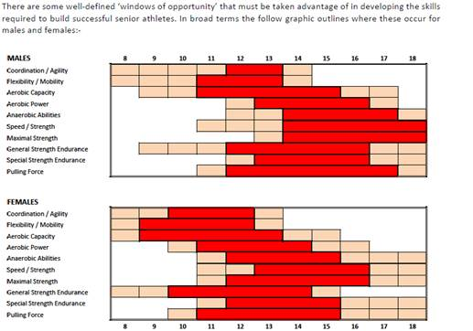
Therefore sessions should be
- Fun and Games
- Gymnastics for mobility
- Agility and coordination for turns
- Coordination for starts
Make sure good techniques are used throughout the exercises and activities
On the first camp you may want to go over the exercises in groups to make sure they know the activities and can do correctly rather than scoring. After that keep to small groups so they can monitor their scores over progressive camps
Key Safety Features to consider—need a risk assessment
- Room size suitable
- Footwear of swimmers—good trainers
- Floor surface
- Temperature of room
- Lighting
- Space between activities
- Any injuries
- Care with forward rolls—make sure mats are available
- Adequate supervision
- Good technique
Warm up—10 minutes
Jogging. High knees. Heel flicks
Stand up sit down
1, 2, 3 games-1 right hand, 2 left hand. 3 both hands
Spiderman crawling/ switches
Standing roll down
Roll down to plank to stand
Downward dog
Kneeling thoracic rotation

- Forward roll
For Turns
Get in starting position. Place your feet together and bend your knees so that you're squatting. Place your hands on the ground in front of you with your elbows bent. Your hands should be evenly spaced at shoulder width. This is the starting position for a beginner's forward roll.
Drop your head between your arms. Be sure to tuck in your chin. As you move into the roll, you don't want to place weight on your neck - it should move directly onto your upper back. Tucking in your chin will help ensure that you don't put pressure on your neck.
Roll forward. Push over onto your upper back, so that your body rolls forward and your hips are pushed over your head. Follow the curve of your spine as you roll. Keep you’re back curved and keep your hands in position.
  - Roll straight forward along your spine. Otherwise, you may fall to one side or the other.
  - Be sure to keep your chin tucked in and you’re back curved. If you straighten out, your roll won't have as much momentum.
Stand without using your hands for support. At the end of the roll, place your feet flat on the floor and move into a standing position without putting your hands on the ground. Straighten your legs, then finish upright with your hands over your head
Activity is forward roll three times then walk back.
Then the next swimmer goes—relay team
Each swimmer completing three rolls is one point

2.0 Overhead backward throw and catch
For Backstroke Start

Use bean bags instead of a ball if restricted space
2 people start with a basket of balls/ Bean Bags in front of them
They squat to pick up a ball. With both hands they throw the ball backwards over their heads
Their partner catches the ball/ Bean Bag
This is one point
If they drop it they do not score
This is repeated until all the balls have been used and then they swap positions
Maximum ball weight 0.5kg

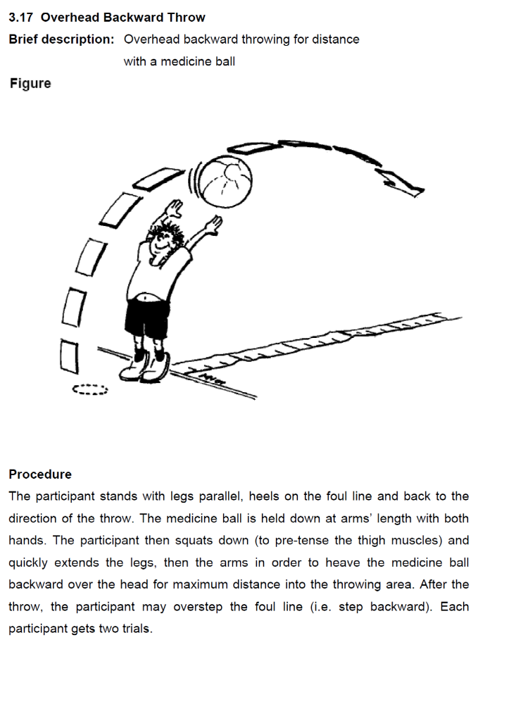

3.0 Forward Hoop jumps
For Starts and Turns
Start by placing 4 hoops approximately 1 metre appart
First person does a standing long jump to the first hoop then second etc
He returns and jumps back
Then the second person starts
Each person jumping there and back is one point
Watch the landing with soft knees and knees aligned with toes

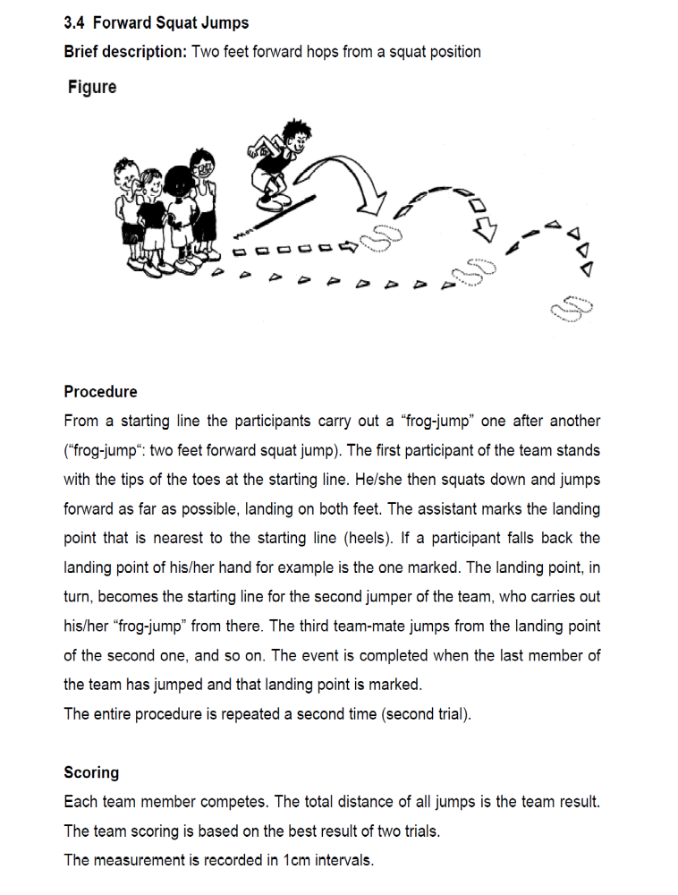

4. Crab Walk
For Glutes, shoulder stability and core strength as required in free swimming
In order to do a Crab Walk correctly, sit on the ground with your legs extended out in front of you. Place your hands by your side with your fingers pointed toward your feet or to the side. Lift your body up into the air. Arch your back up as far as you can making sure your glutes are tight. Now in this position, begin to step forward one hand after the other. As you walk don’t let your bottom drop. When you get to the end of the course where the cone is turn around and go the other direction. Then the next person goes in the team.
Each person going there and back is one point
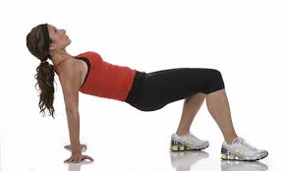

5. Freestyle legs overhead
For turns
Lying on your back bring your legs over your head to touch the floor behind the head
Each swimmer takes it in turns to do 10 kicks then the next person does 10 kicks. This is 1 point for the team.
The second person then does the kicks in a relay fashion until all 4 have done it. The first one starts again
If the feet don’t touch the floor it doesn’t count as a point
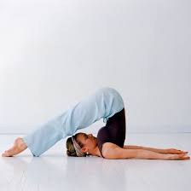

6. Wheelbarrow
For streamline, shoulder stability and core strength
To make a wheel barrow, get down on all fours and have your partner stand behind you. Have your partner carefully lift up your legs while you support yourself with your hands. Make sure your core is contracted so your back is straight and not arched.
Walk to the end cone and switch positions with your partner, and go back to the starting line.
One point for each return wheelbarrow run
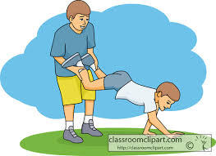

7. Sit Stand and rotate
For rotation control in freestyle and Backstroke including turns
From sitting stand without using the hands
Then Jump and do a half turn—land on soft knees
Sit back down and repeat
Each cycle is one point (sit to stand to turn to sit)
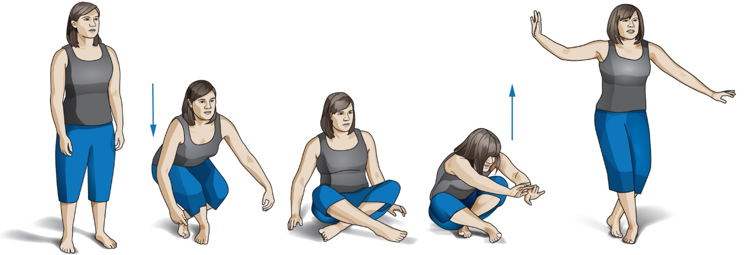
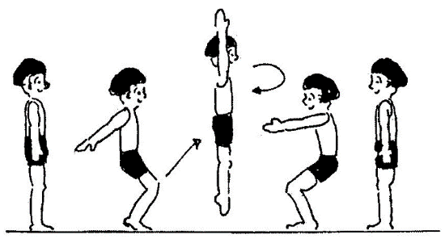

8. Hand to toe walk
For body position in free swimming and streamline
Pike position for turns
Start with the feet shoulder width apart and knees straight. Bend from the hips and touch the hands on the floor—for those with limited hamstring movement they will have to take their hands forwards slightly
Walk the hands forward to a plank position
Make sure a good back position is maintained.
The walk the feet into the hands
Repeat moving the hands forwards again to plank then feet in to hands
The swimmers moves to the cone and back when the next person starts
Each swimmer going there and back is one point.
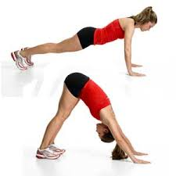

9. Arabesque ball pass
For racing starts
Stand 3 feet away from partner
Stand on the right leg and lean forwards into a flexed position at the same time as straightening the left leg and reaching the football forwards.
The partner does the same movement to collect the ball.
Both then stand and change legs and repeat.
Each ball pass is one point
The technique must be done carefully
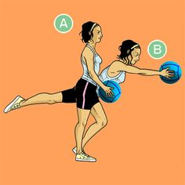

Activities
9 stations
Groups of 4 swimmers
Each has recording sheet
Timed activities 1 minute

Layout of Land Area
To forward rolls
Arabesque Ball pass
2 balls
Hand to toe walk
2 cones
Stand sit rotate
Wheelbarrow
2 Cones
Freestyle legs overhead
Mats
Crab walks
2 Cones
Forward Hoop jumps

Hoops x 4
Backward Ball throw
Weighted ball< 0.5Kg
Forward rolls
MATS
Equipment Required
8 Mats
Either 10 soft weighted balls (max 0.5Kg) or 10 bean bags
4 hoops
12 cones
2 footballs

After the session if this is the last activity of the day make sure a group stretch and mobilise session is performed—10 minutes

Scoring Sheet

Group Name:
Swimmers names:
1.
2.
3.
4.
Activity | score | Total score
Forward Rolls |  | Total score
Beanbag throw and catch |  | Total score
Forward hoop jumps |  | Total score
Crab walk |  | Total score
Freestyle legs |  | Total score
Wheelbarrow |  | Total score
Sit to stand jump rotation |  | Total score
Hand to toe walk |  | Total score
Arabesque ball pass

